**GIT HUB DOCUMENTATION (For Beginner)** :

**GitHub** is a [web-based hosting service](http://en.wikipedia.org/wiki/Shared_web_hosting_service) for software development projects that use the [Git](http://en.wikipedia.org/wiki/Git_(software)" \o "Git (software)) [revision control](http://en.wikipedia.org/wiki/Revision_control) system. GitHub offers both paid plans for private repositories, and free accounts for open source projects.

The site provides [social networking](http://en.wikipedia.org/wiki/Social_networking) functionality such as feeds, followers and the [social network graph](http://en.wikipedia.org/wiki/Social_network_graph) to display how developers work on their versions of a repository.

The software that runs GitHub was written using [Ruby on Rails](http://en.wikipedia.org/wiki/Ruby_on_Rails) and [Erlang](http://en.wikipedia.org/wiki/Erlang_(programming_language)" \o "Erlang (programming language)) [[12]](http://en.wikipedia.org/wiki/GitHub#cite_note-12) by GitHub, Inc. (previously known as Logical Awesome) developers Chris Wanstrath,[[13]](http://en.wikipedia.org/wiki/GitHub#cite_note-13) PJ Hyett, and Tom Preston-Werner.

**How To Work With GIT (Remote In GIT server):**

1. Firstly to make an account in GITHUB first.
2. Create a new Repository with any name example project name, then navigate to the first page using [www.github.com](http://www.github.com) .
3. Once you come to the Login Page, it will show you, your repository in the bottom (which you already created).Follow the screen shot.

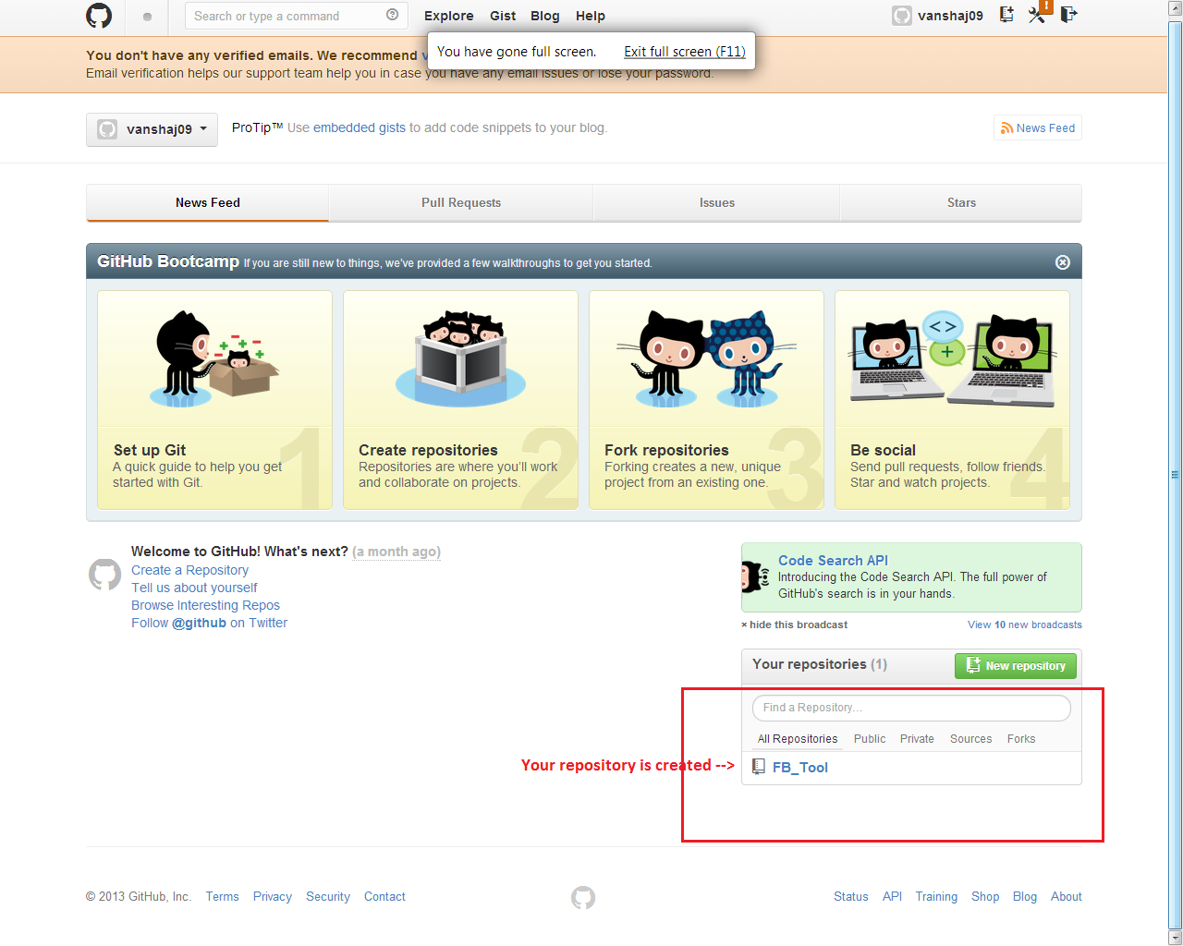

1. On clicking on your repository you get your project folder in the GIT HUB. Along with this, GITHUB is providing you README file as a default file in the folder, because GIT never stored the empty folder. Follow the Screen Shot.

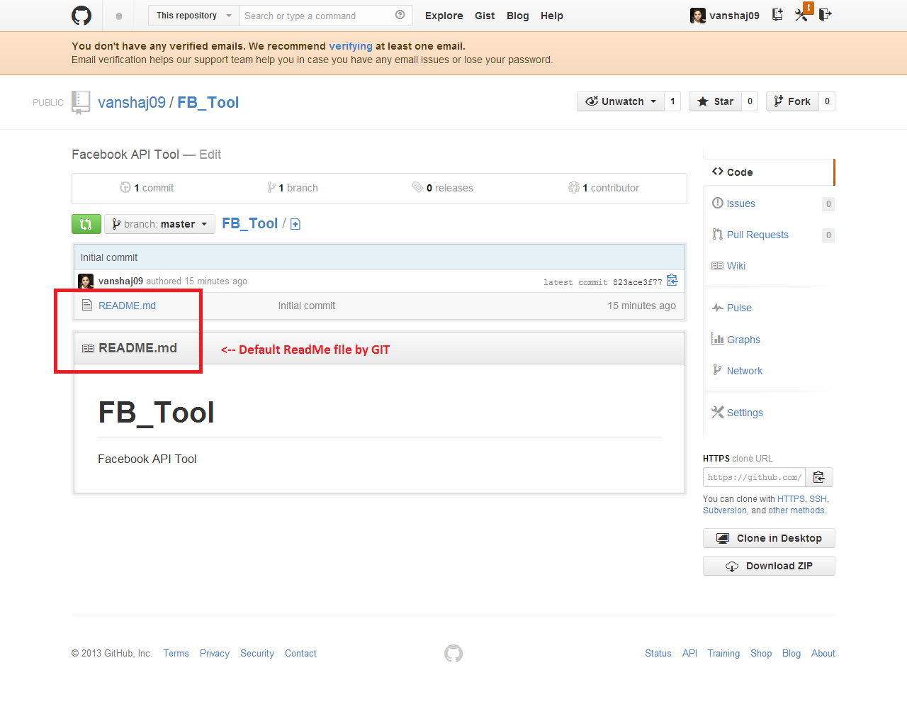

1. This file or repository file, is a remote file and this is in GIT server, here we can push and pull the changes.

**How To Work With GIT (Local Machine):**

1. For creating the file or upload the files or we can say if we want to push the file in the GITHUB so we have to create one folder as master folder in local, for creating a folder into local Machine, we have to clone the HTTPS url from your GIT account each repository having individual URL.We have to copy the URL using  button which is in the bottom. Please follow the given screen shot

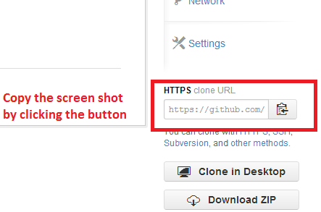

1. Then go to the CMD (command prompt) of GIT for cloning that files from remote machine to the local machine. For cloning the folder or creating the folder in local machine please follow the screen shot.
   1. Firstly you have to select where you want to store your project folder,here I am taking d:/GIT_DATA folder
   2. Once we clone the file to the local machine so that folder is the master folder for your local machine which is directly linked with the GITHUB.

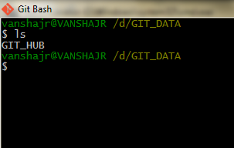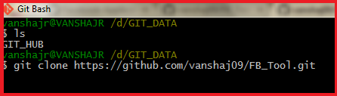

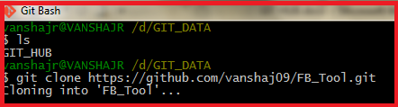

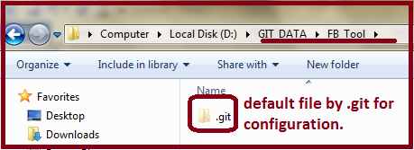

* 1. File is created in your Local Machine using **$ git clone “ Copied-URL “**. The file is created in your given drive, that means the clone of your remote folder is created in your local machine.

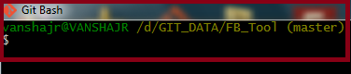

1. Now we will add a new file in the GITBASH i.e. in your local machine once you add the file you have to commit because if you not commit the file it is not in your local master folder, here we have two scenario
   1. Pull: Pull the data from the remote machine to the local machine.

Command : $ git push

* 1. Push: Push the file or data into your own local machine, then after commit again push the data to the local machine to the remote machine that means in GITHUB. Here push means If we have a file abc.html and I want to add one <img> tag in the html page so I have to pull the data from the remote machine to our local machine and then we can alter the things or add the <img> tag into that file and push the data into remote machine. Here there is something need to know, once you pull the data from the GIT after alteration on the file we have to first commit the file then we can push that file into remote using push.

1. **For Adding new file** from local machine so easily we have to copy that file and put it in the master folder. Now check the file into GITBASH using **$ls** command.

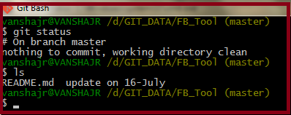

Here we get the two files in the folder FB_Tool which is master, one is **README.md** which is default and another structured folder is **update_on_16-July.**Below is the Path..

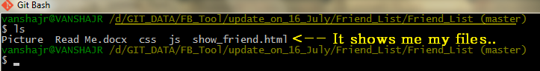

**$ git status is used for check the status of the master, like if we add a new file and we are not commit yet so it will show me a message like. (screen shot)**

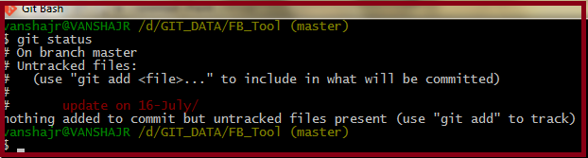

That means we update one file in a folder but we can’t commit yet so for commit the file we have to use **$ git commit –m “File Name”.**

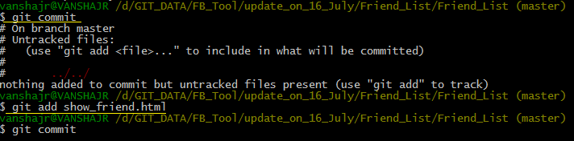

Once you add and commit the file it is ready to pull to the remote ie GITHUB. Now we push the file to the Remote Machine using **$ git push**

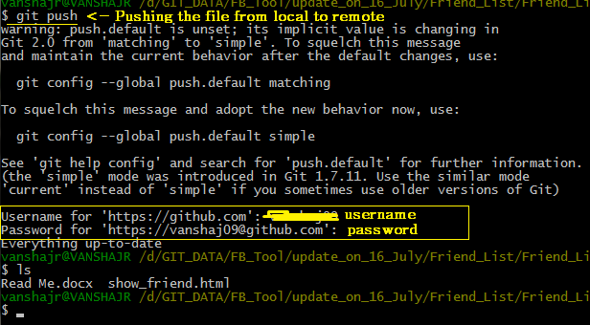

After that you have to put your Username & password and press enter key, your file will upload in your remote machine.

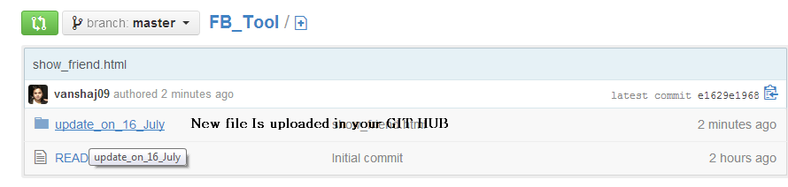

This is the basic understanding to work with GIT for pushing the data from local machine to remote machine.

USED COMMANDS :

$ls -> To show the list of the given directory.

$ git clone -> It is used to create a master page that means a clone folder in your local machine.

$ git status -> To know the status of the local git machine.

$ git add -> To add a new file in the machine, this file is not stored in the remote machine, it only indicates that file is add, but before using the commit & push command the file is not be in the remote machine (GITHUB).

$ git commit -> After adding a file into machine we have to commit the file and push the file.

$ git push -> Is used to push the file to the remote machine.